Software Testing Assignment

# Module–1(Fundamental)

1. What is SDLC :

* SDLC is a structure imposed on the development of a software product that design the process for planning, implementation ,testing ,documentation,deloyment and ongoing maintenance and support.

1. What is agile methodology?:

* Agile SDLC model is a combination of iterative and incremental process models with focus on process adaptability and customer satisfaction by rapid delivery of working software product. Agile Methods break the product into small incremental builds. These builds are provided in iterations. Each iteration typically lasts from about one to three weeks.Every iteration involves cross functional teams working simultaneously on various areas like planning, requirements analysis, design, coding, unit testing, and acceptance testing. At the end of the iteration a working product is displayed to the customer and important stakeholders

1. What is SRS

* A software requirements specification (SRS) is a complete description of the behavior of the system to be developed,there are two types of Requirements Functional and Non functional.

1. What is ops

* Identifying objects and assigning responsibilities to these objects. Object-oriented programming has a web of interacting objects, each house-keeping its own state

1. Write Basic Concepts of oops

* Object
* Class
* Encapsulation
* Inheritance
* Polymorphism –

- Overriding

- Overloading

* Abstraction

1. What is object

* Object Can Be Anything Any person,Car,Colour,Shape Etc.
* Object is an instance (Example Of Class),Object Can Have a single class
* Object can communicate with other object Using methods of Functions.

1. What is class

* Class is blueprint for an object
* There are have many object in class

1. What is encapsulation

* Encapsulation is a process of Rapping of a data into a single unit. For Example Class can containt method and data & method and data Encapsulated class.

1. What is inheritance

* Inheritance Shows Parent Child relation in Which Child Can inheret Properities and Charterristict of the class.

1. What is polymorphism

* Poly Means Many,Morphi Means Forms. Polymorphism is something that can have same Name And Same Behaviour.

1. What is RDBMS
2. What is SQL
3. Write SQL Commands
4. Draw Usecase on Online book shopping

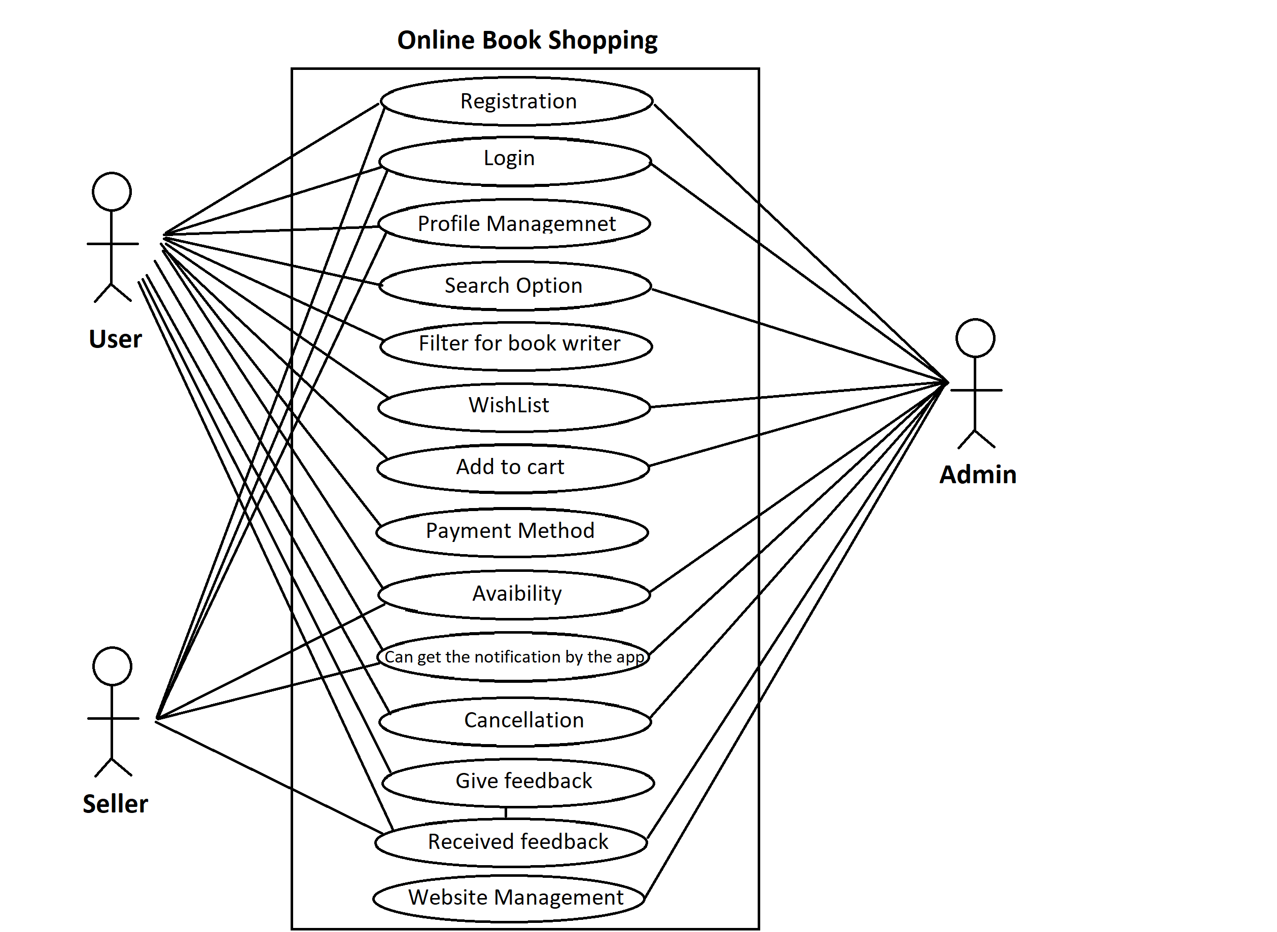

1. Draw Usecase on online bill payment system (paytm)

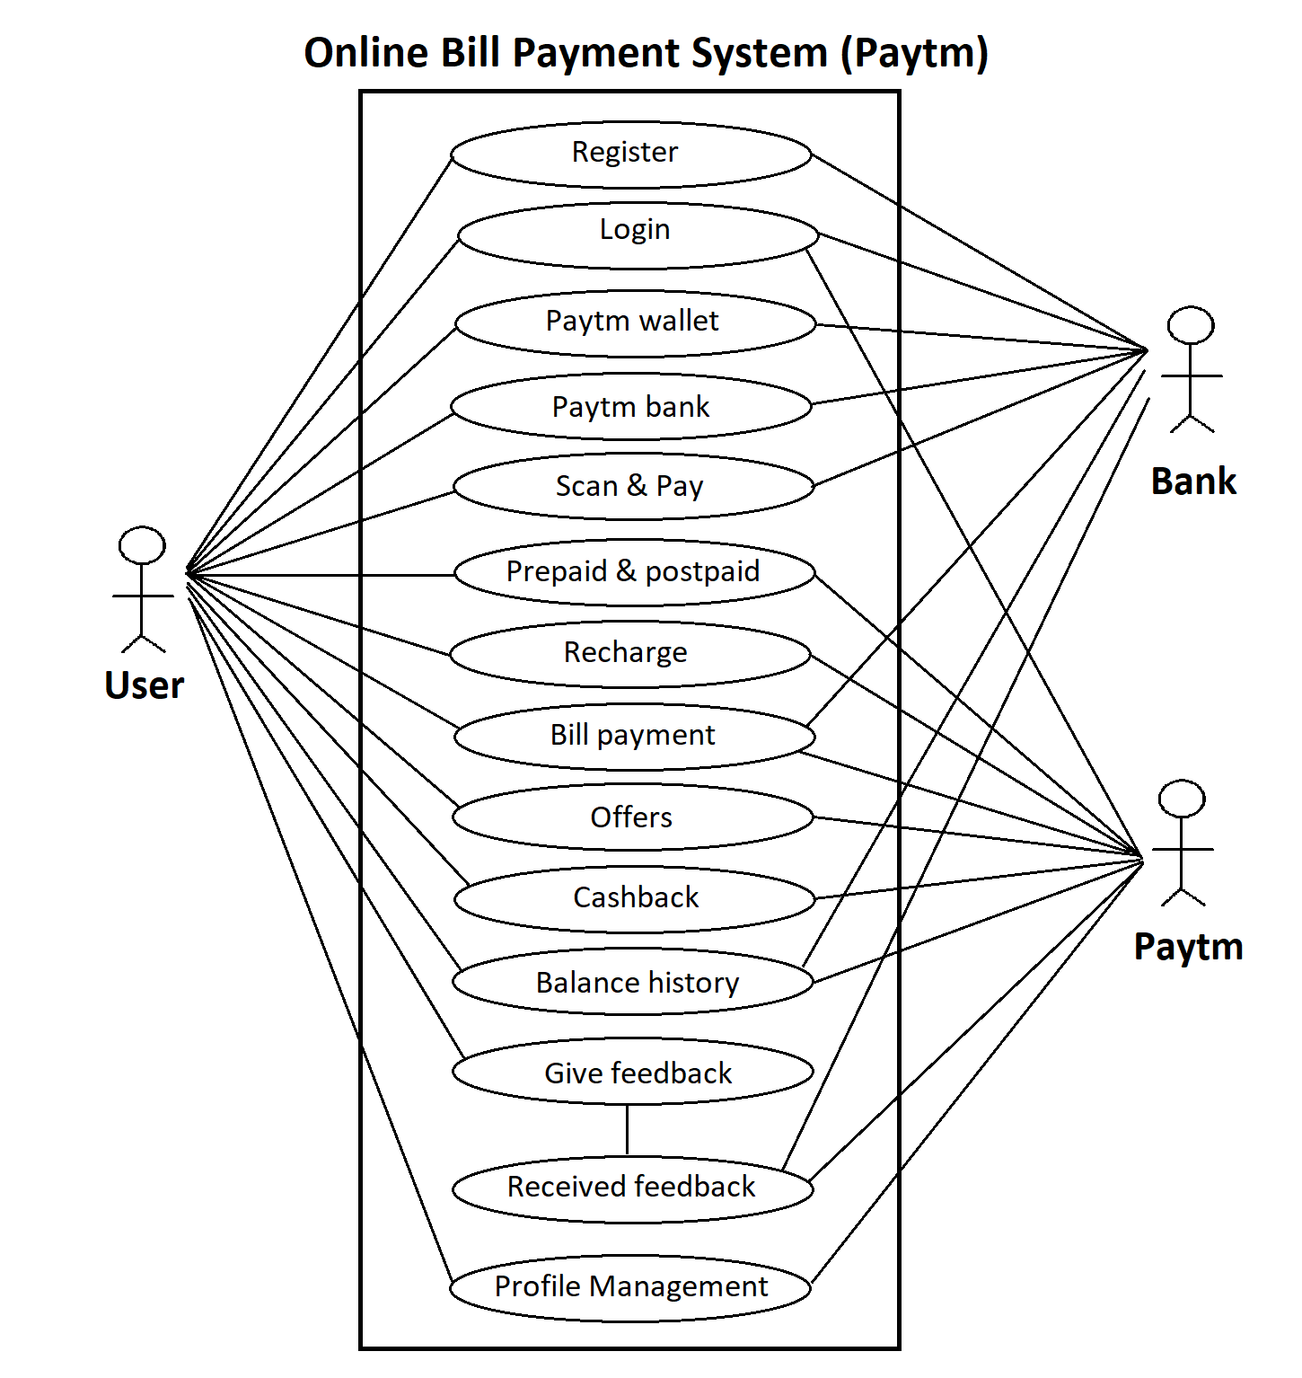

1. Write SDLC phases with basic introduction: below SDLC Phases

* 1.Requrement : Establish Customer Needs
* 2.Analysis : Model And Specify the Requirement “What”
* 3.Design : Model And Specify A soultion “Why”
* 4.Implemenation : Constuct A soultions In software
* 5.testing : Validate The soultions against the Requirement
* 6. Maintenance : Repaire defects And adapt the soultions to the review requirement.

1. Explain Phases of the waterfall model:

* waterfall Model also known as Classical software model ,In waterfall Model Requirement must be FROZEN to early in the life cycle & Also Requirement are validate too late,
  + - * 1. When document are clear and fixed then we can waterfall model, product stable and technology easy to understood ,no Ambiguous Requirement that time waterfall model is very useful
        2. Waterfall model also use for short term project.

1. Write phases of spiral model.

* Spiral Model is very widely used in the software industry as it is in synch with the natural development process of any product i.e. learning with maturity and also involves minimum risk for the customer as well as the development firms.
* Following are the typical uses of Spiral model:

1. When costs there are a budget constraint and risk evaluation is important.
2. For medium to high-risk projects.
3. Long-term project commitment because of potential changes to Customer is not sure of their requirements which are usually the case.
4. Requirements are complex and need evaluation to get clarity.
5. New product line which should be released in phases to get enough customer feedback.
6. Significant changes are expected in the product during the development cycle.
7. Write agile manifesto principles:

* Individuals and interactions - in agile development, self-organization and motivation are important, as are interactions like co-location and pair programming.
* Working software - Demo working software is considered the best means of communication with the customer to understand their requirement, instead of just depending on documentation.
* Customer collaboration - As the requirements cannot be gathered completely in the beginning of the project due to various factors, continuous customer interaction is very important to get proper product requirements..
* Responding to change - agile development is focused on quick responses to change and continuous development.

1. What is join?
2. Write type of joins
3. Explain working methodology of agile model and also write pros and cons.

* pros

1. Is a very realistic approach to software development
2. Promotes teamwork and cross training.
3. Functionality can be developed rapidly and demonstrated.
4. Resource requirements are minimum.
5. Suitable for fixed or changing requirements
6. Delivers early partial working solutions.
7. Good model for environments that change steadily
8. Minimal rules, documentation easily employed.
9. Enables concurrent development and delivery within an overall planned context.
10. Little or no planning required
11. Easy to manage
12. Gives flexibility to developers

* Cons :

1. Not suitable for handling complex dependencies.
2. More risk of sustainability, maintainability and extensibility.
3. An overall plan, an agile leader and agile PM practice is a must without which it will not work.
4. Strict delivery management dictates the scope, functionality to be delivered, and adjustments to meet the deadlines
5. Depends heavily on customer interaction, so if customer is not clear, team can be driven in the wrong direction.
6. There is very high individual dependency, since there is minimum documentation generated.
7. Transfer of technology to new team members may be quite challenging due to lack of
8. Draw usecase on Online shopping product using COD.

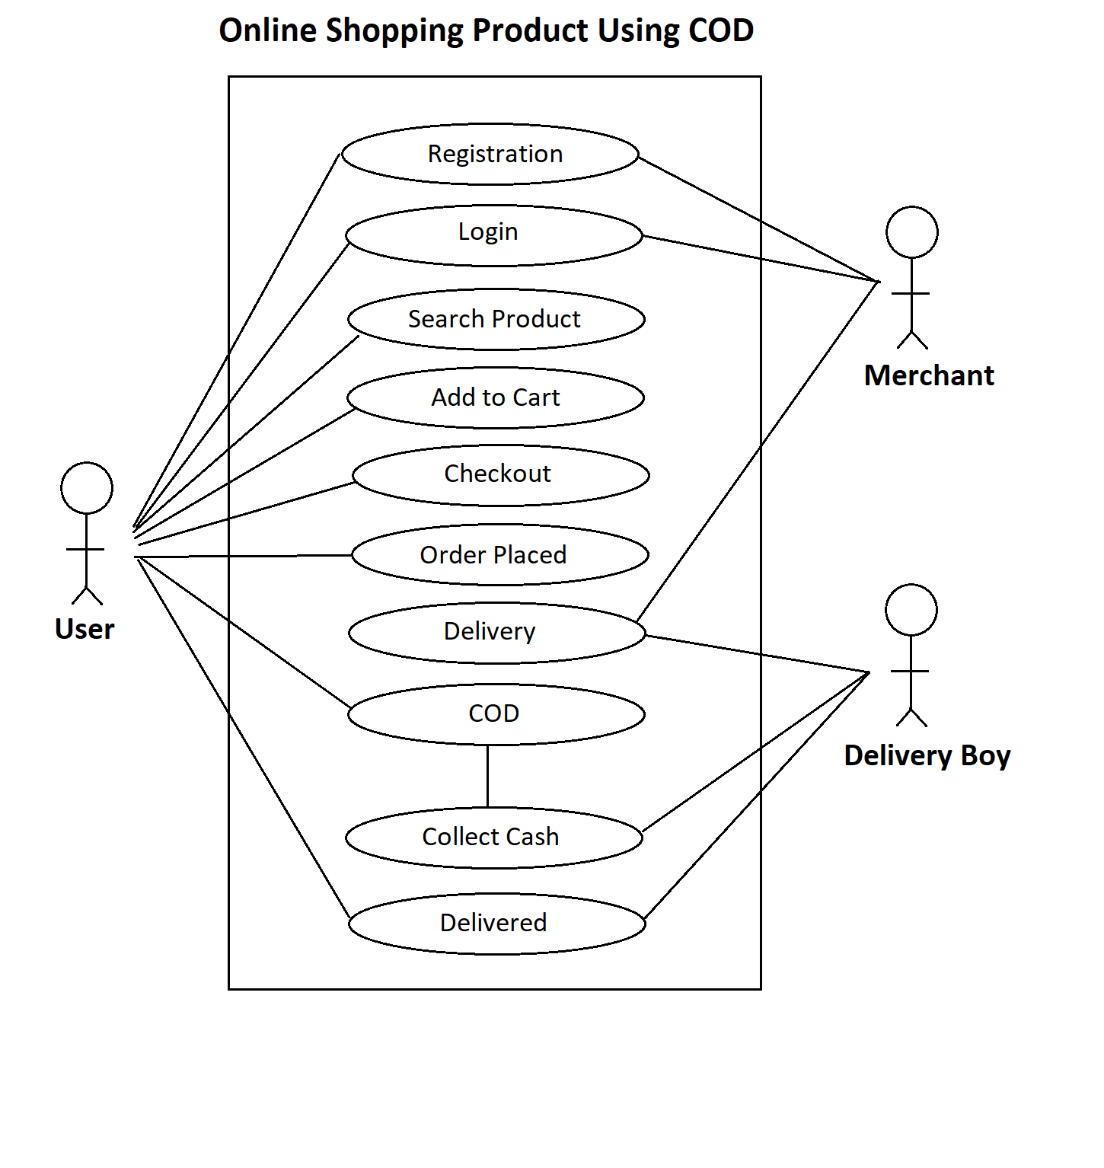

1. Draw usecase on Online shopping product using payment gateway.

